**REVEILLE OIL AND GAS SERVICES NIGERIA LIMITED**

**WHO WE ARE**

We are a team of professionals working together to build a one-stop-shop for all machine shop needs in the oil and gas industry especially in servicing of drilling tools and pipes. We still stand out as the foremost indigenous company in the field that started from the scratch with only local personnel/experience and delivering world class quality services which is evident in our fast-growing customer base.

Our services are delivered through a number of dedicated, highly skilled engineers and technicians capable of providing custom designed solutions for each specific problem relevant to the oil, energy and gas exploration industries.

The Reveille Machine shop is fully equipped with several manual and Computer Numerical Controlled (CNC) machine tools capable of handling the threading of any size of pipe (casing, tubing, drilling) and machining of large size work pieces. Quality remains our watch word and we strive to maintain our competitive advantage of better, cheaper and timely delivered products and services.

We take pride in each and every product that we manufacture, and it only leaves our workshop if it gets our quality stamp/approval.

**REVEILLE OIL AND GAS SERVICES NIGERIA LIMITED** has been accredited and registered by the Standards Organization of Nigeria (SON) with **ISO 9001 : 2015** (Quality Management System) and has also been certified by the American Petroleum Institute (API) and have the following licenses:

* API Spec 5CT
* API Spec 7 – 1
* ISO 9001 : 2015

In addition to the above services, **Reveille** also has a wide range of Fishing and Drilling tools available for rentals. These include all sizes and types of Subs, Stabilizers (steel and non-magnetic), Hole Openers, Jars and various types and sizes of Mills/Shoes etc.

Our customer base has constantly grown from year to year and we are already positioned to be one of the foremost indigenous Oil and Gas Services Companies in the coming years.

**REVEILLE OIL AND GAS SERVICES NIGERIA LIMITED** operational Base/Workshop is located at Km. 3, Igbo-Etche Road, By Eleme Junction, Port Harcourt, Rivers State, Nigeria, occupying about 12,000 Square Meters of yard area including Offices, Warehouse/Machine Shop, pipe racks and storage areas.

QUALITY POLICY STATEMENT

To provide products and services that conform to requirements, meet clients’ needs, exceed client expectations and are delivered in a cost-effective manner.

MISSION STATEMENT

To deliver products and services of the highest quality that ensures financial growth through innovative and responsive solutions using a highly motivated team and satisfying the interest of our stakeholders in an environmentally friendly manner.

VISION

Our vision is to be a premier and highly professional machine shop, fabrication and tools rental service company in Nigeria that compares favorably with the best anywhere in the world.

OUR SERVICES

MACHINE SHOP SERVICES

Our machine shop is a standard and well-equipped threading and OCTG facility with specialization in the cutting and recutting of all types and sizes of API/Rotary shouldered connections(threads)

Our facility is duly certified by the America Petroleum Institute (API) to carry out these services and we have maintained these certifications since 2015.

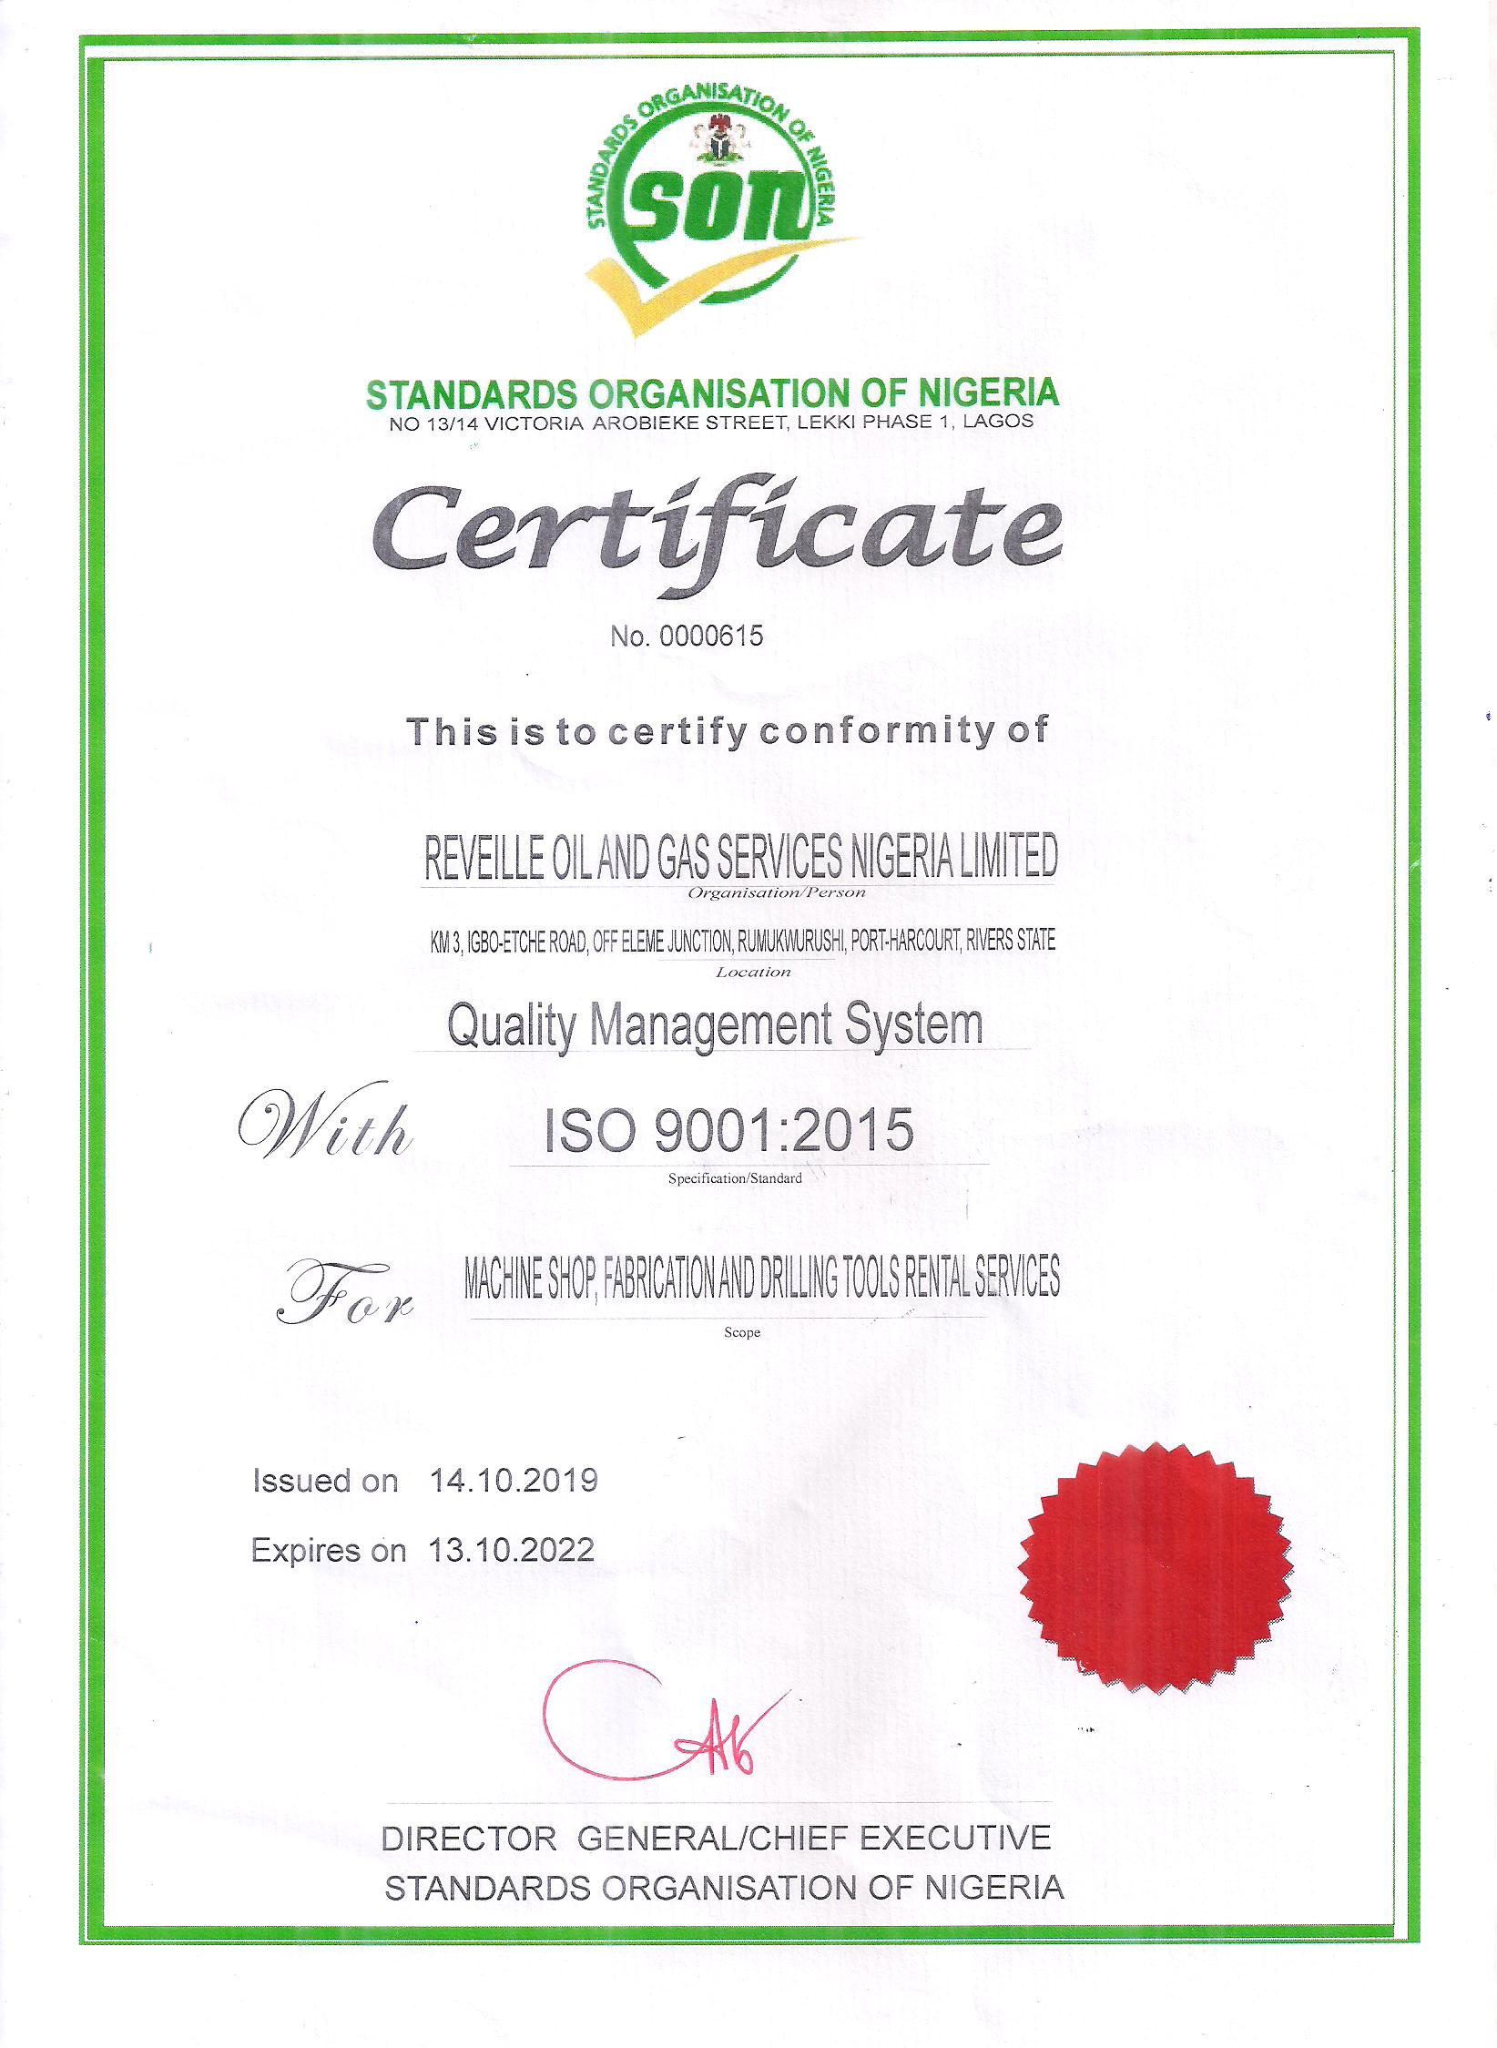

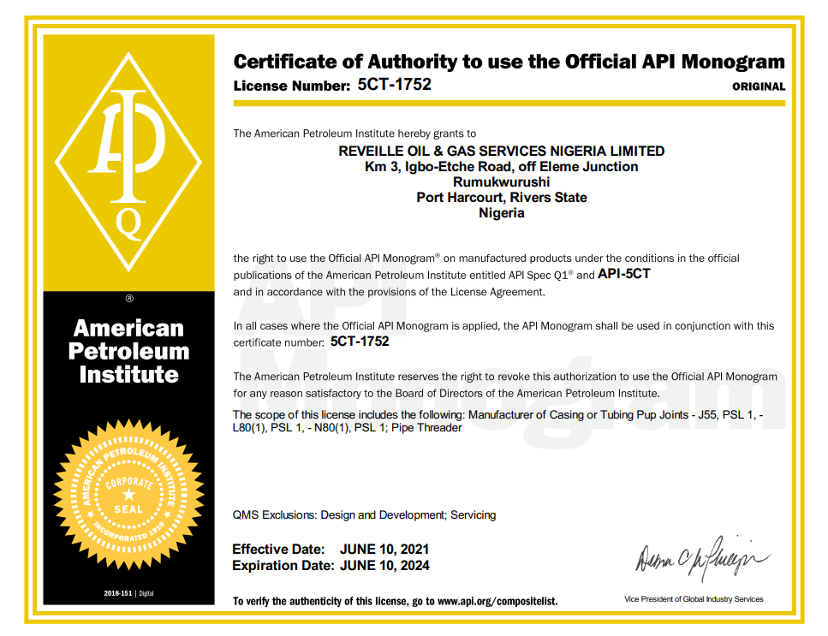

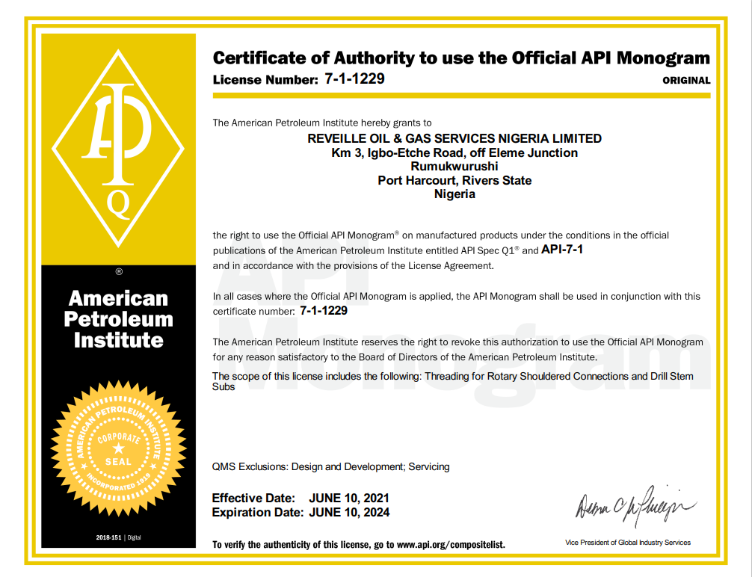

We have and maintain wide range of original API thread gauges for the threads

The company also imports, supplies and maintains Bar stock of 4140H and 4145H steel materials for the manufacture of different sizes of subs at short notices and any specifications as the client might require.

We Also provides the following machine shop services.

1. OCTG and API Threading
2. Threading of Casing and Tubing pipes (and pup joints)
3. Threading of Drill Pipes, HWDPs and Drill Collars
4. Manufacture and Repair of Drill stem subs, Casing, Cross Overs, Side entry Subs, Float subs, UBHO Subs, Bit subs, saver subs, Lift subs and Top Subs.
5. Manufacture and modification of different types and sizes of flanges and Ring Groves.
6. Manufacture, repair and modification of Oil drilling and Well completion tools and services.
7. Manufacture, Refurbish, repair and modification of pump modules (Mud Pumps), Well Heads modification and Xmas trees.
8. Manufacture and repair of Well Head equipment, pressure control and flow control equipment.
9. Repair and modification of Spools, Flanges and BOP Test stumps.
10. Manufacture and supply of Metal and Teflon drift Mandrels.
11. Manufacturing, Machining and repair of marine shafts, Key ways, etc
12. General Machining services- Drilling, Tapping, Milling
13. Dimensional and conformity checks (inspection) on tools, parts etc

OCTG Casing and Tubing Supply and Repair Services

1. Threading and rethreading of all sizes of casings and Tubings
2. Manufacture of Casing Pup Joints and Cross-Overs
3. Supply of Thread couplings for all sizes of Casing and Tubings
4. Break-out and Bucking services

Our Bucking unit is ideally suited to the bucking or make-up of

* Pup joints
* Couplings
* Centralizers
* Assembly of BHA’s
* Completion equipment
* Parker Assemblies
* Stage Tools
* Cement Assemblies
* Any equipment that needs to be rig ready prior to arrival at the rig site

The unit can also handle the unbucking/ breakout of the following.

* Drilling/Casing tools
* Centralizers
* Removal of couplings from Casings/Tubings
* Disassembly of Bottom Hole Assemblies (BHA’s)
* Any other down hole tools that are seized and cannot be broken apart at the rig.

TOOL RENTALS AND SUPPLY SERVICES

Supplies

* Warehouse Lifting equipment
* Electric Hoists
* Chain Blocks
* Over Head Cranes
* Casings and Tubing Couplings up to 20”
* Thread Protectors
* Bar stock of 4140H and 4145H steel materials

TOOL RENTALS

Reveille has a Tool Rental section which has a wide variety of both drilling and fishing tools available for rentals and outright sales as the client might require.

The Drilling Tools inventory includes Steel and non-magnetic stabilizers (5-1/2’’ to 26’’), steel and non-magnetic drill collar (4-3/4’’ to 9-1/2’’), Pony collars and different sizes/types of subs.

WELDING AND FABRICATION SERVICES

Our welding and fabrication services include but not limited to the following.

Fabrication and repair of Offshore cargo Baskets, Tanks and other items like:

* Tools Boxes
* Gas Racks
* Tool Racks
* Pipe Racks
* Other structural fabrications.

Manufacture, supply, and repair of Spools

* Space Spools
* Riser Spools
* Drilling Spools
* Riser Flange

Fabrication, Supply and Repair of BOP test Stumps, and Xmas trees

Fabrication of specialized tools for drilling and completion

Fabrication of side Entry subs (with WECO Connections)

Welding and fabrication of large sized conductor pipes and connectors

Pipeline Fabrications and Installations.

General welding and fabrication services (Onshore and Offshore)

Redressing and grinding of stabilizers, mills, shoes and other tools.

